# [**Windows Server Security Specialist**](https://simplonline.co/classrooms/dc64716a-497e-4aff-b587-cfe318930272/briefs/6668c6d0-cfef-463b-a184-e44f22e20111)

## **Project Overview**

The goal of this project is to build a fully functional Windows Server environment with Active Directory (AD), configure it securely, and conduct penetration testing using various tools. These tools include Mimikatz, CrackMapExec, and BloodHound, among others. A Windows 10/11 VM will be joined to the AD domain to enable practical testing. This project aims to develop proficiency in both system administration and security assessment.

### **1. Setup of Windows Server and Active Directory (AD)**

#### **a. Initial Configuration:**

* **Assign Static IP:**

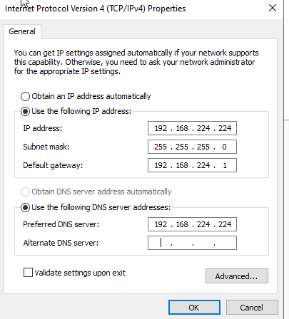

* **Configure Hostname:**

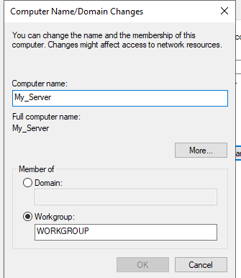

* **Update Windows Server:** Install the latest updates and patches for Windows Server to ensure the system is secure.

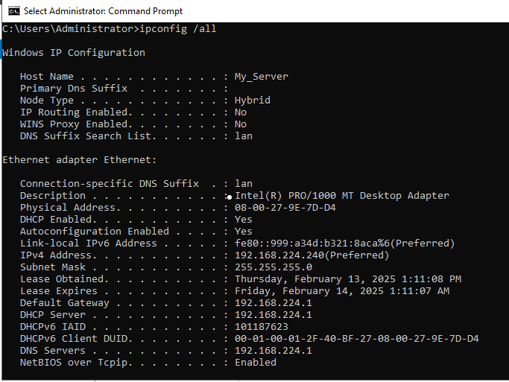

#### **b. Install and Configure Active Directory Domain Services (AD DS):**

* **Install AD DS Role:** Add the Active Directory Domain Services role through Server Manager.

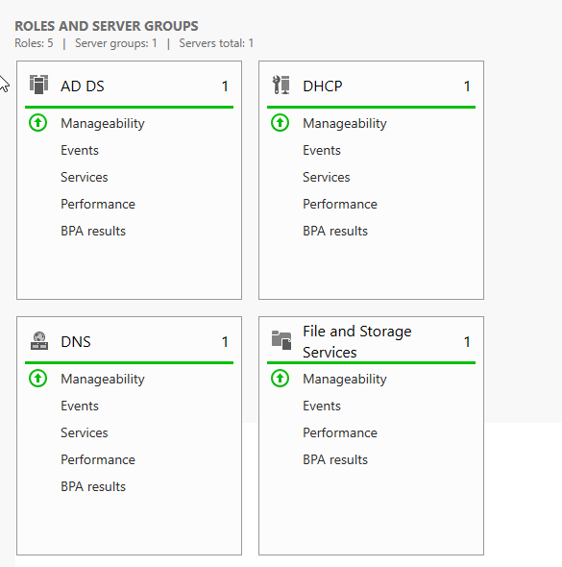

* **Promote to Domain Controller:** Promote the server to a domain controller with the domain name *test.com*

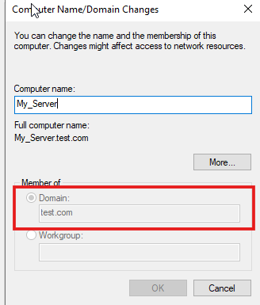

* **Configure DNS:** Set up the DNS server to resolve domain names within the AD environment.

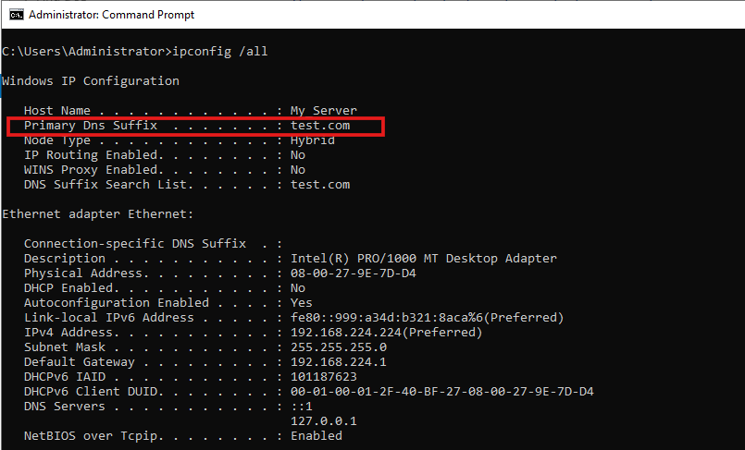

#### 

#### 

#### **c. Organizational Structure:**

* **Create Organizational Units (OUs):**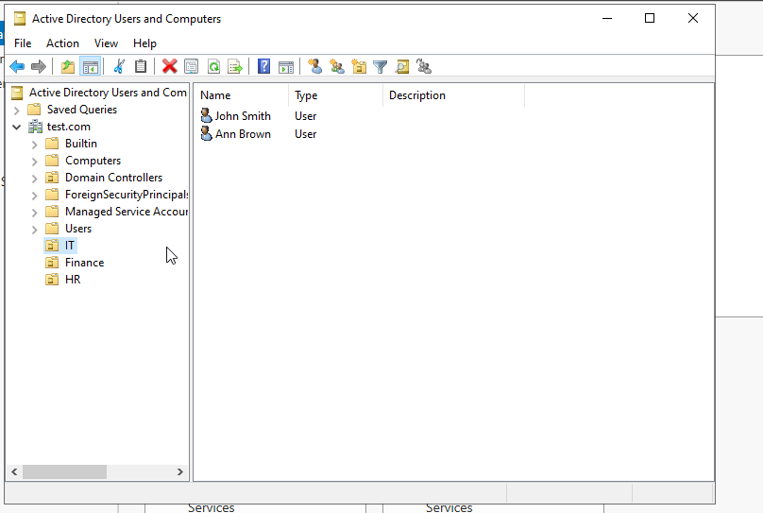
* **User Accounts and Groups:** Create user accounts for both administrative and standard users. Also, create security groups for access control.

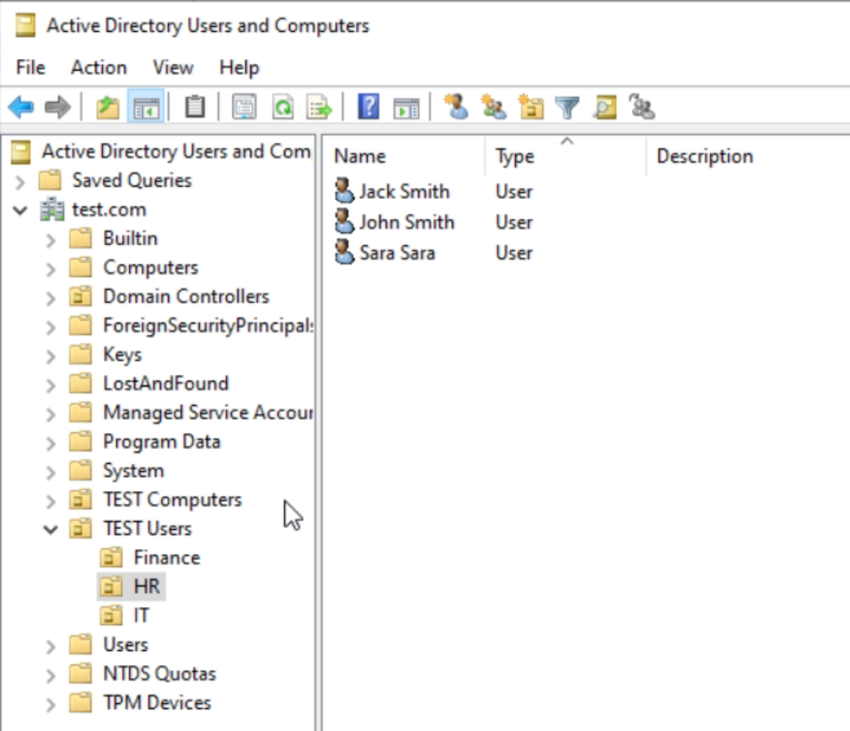

* **Group Policies:** Apply appropriate group policies to enforce security and access control settings.

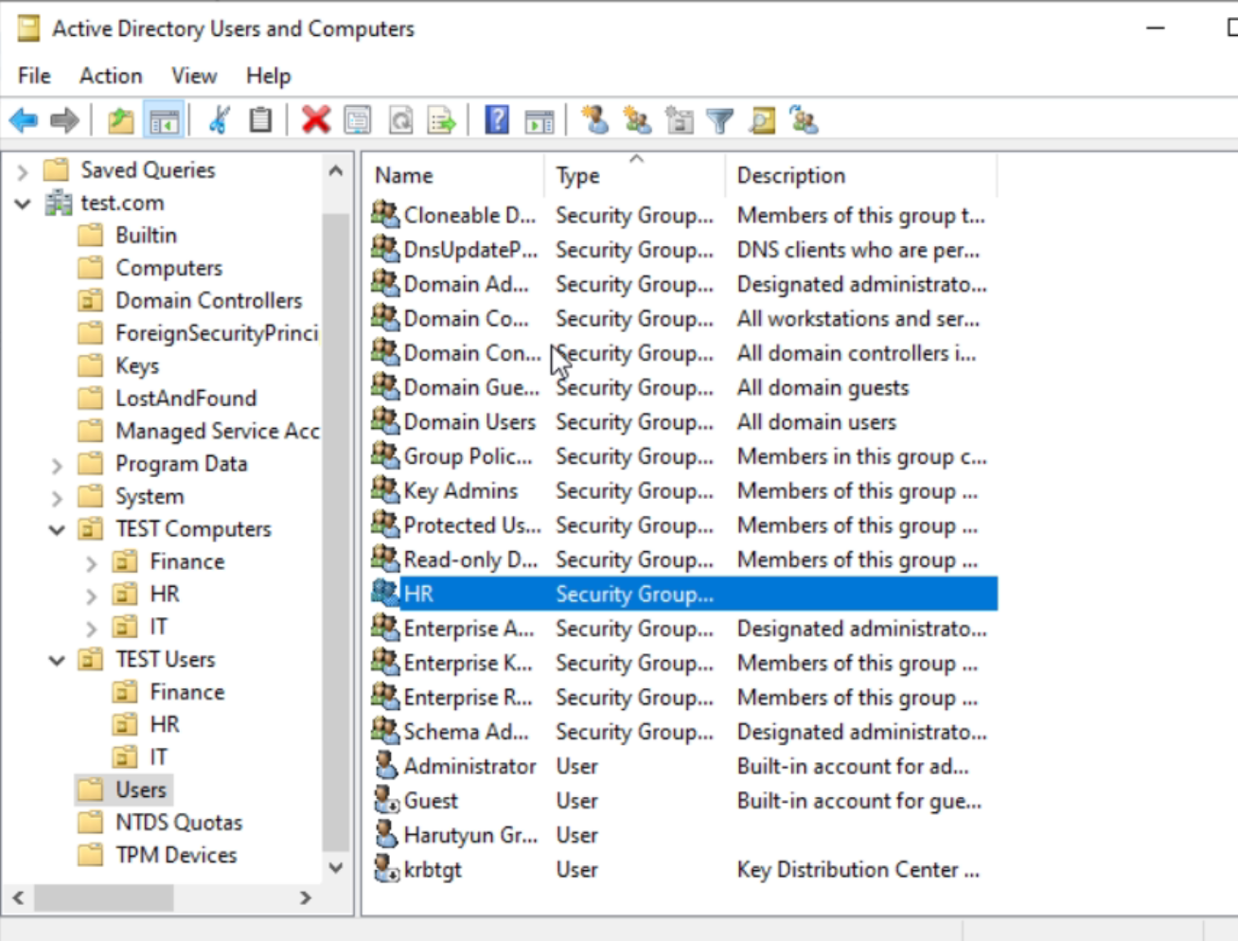

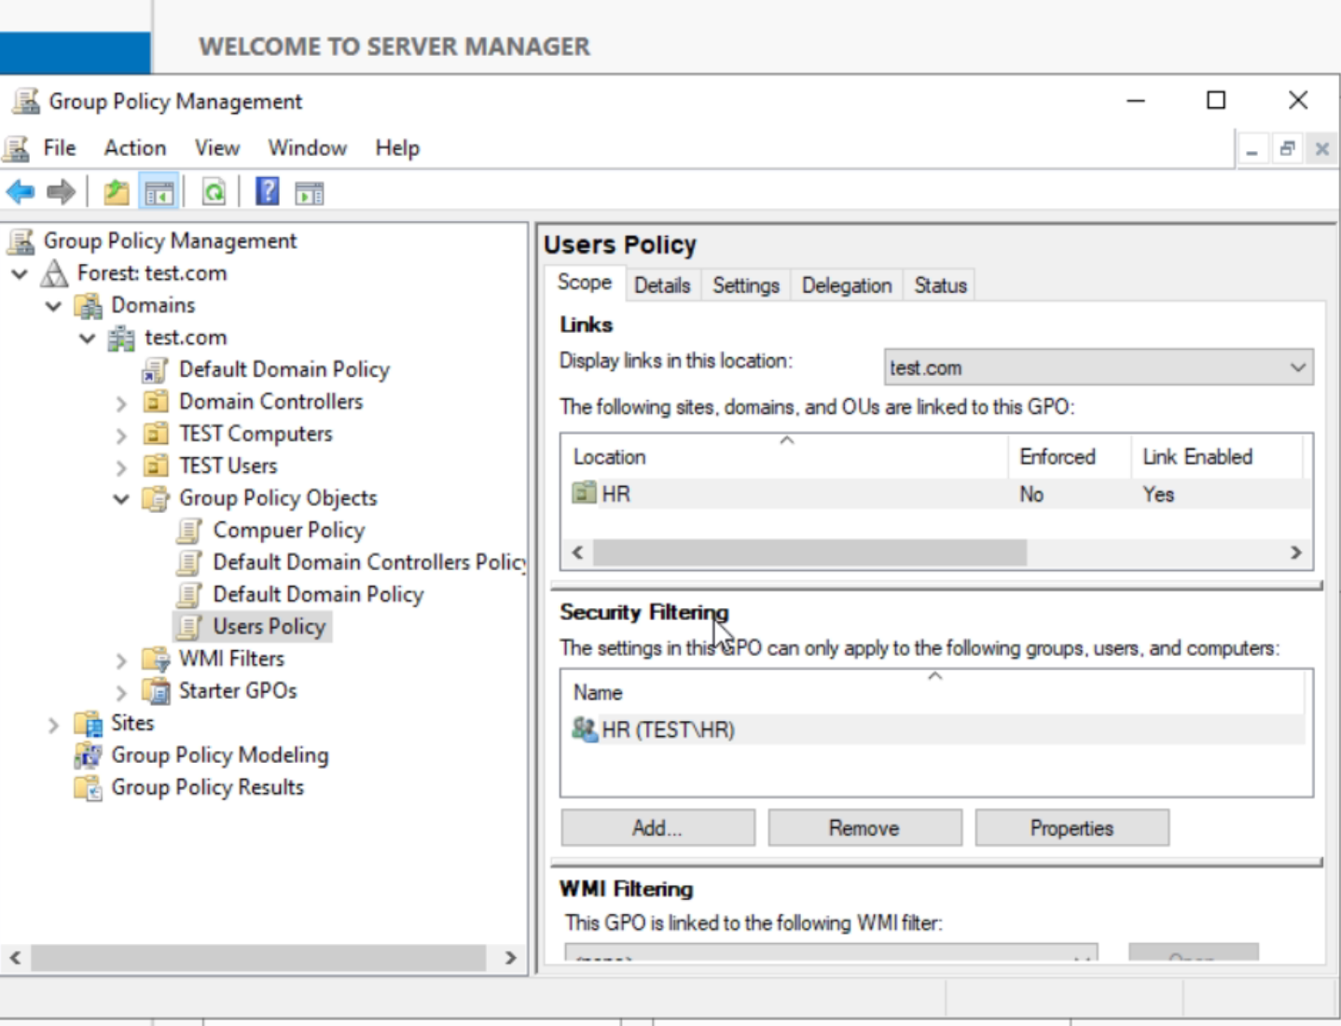

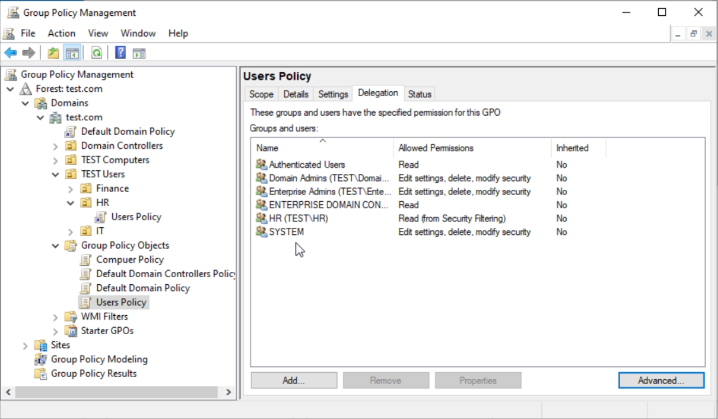

### 

### 

### 

### 

### 

### 

### **2. Join Windows 10/11 VM to the Domain**

#### 

#### **a. Installation and Configuration:**

* Install and configure Windows 10/11 on a VirtualBox VM.
* Connect the VM to the same virtual network as the Windows Server.

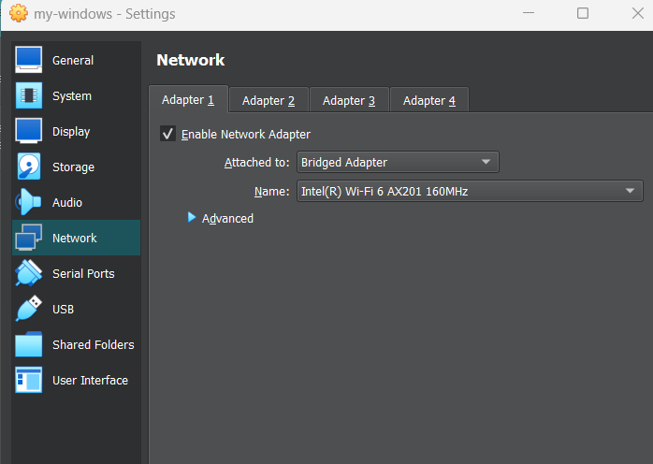

* Join the VM to the domain using the " Domain" option in the system settings

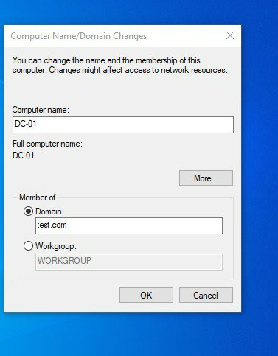

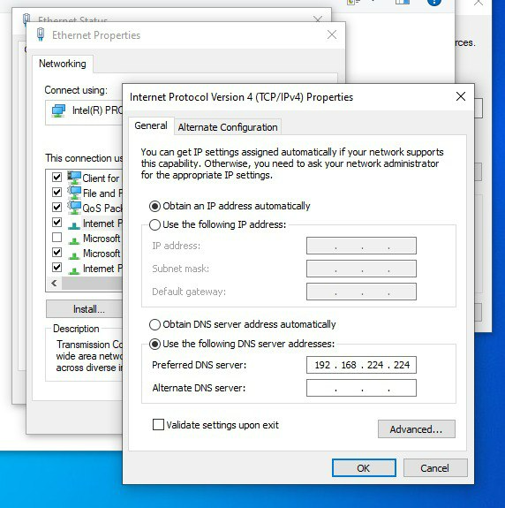

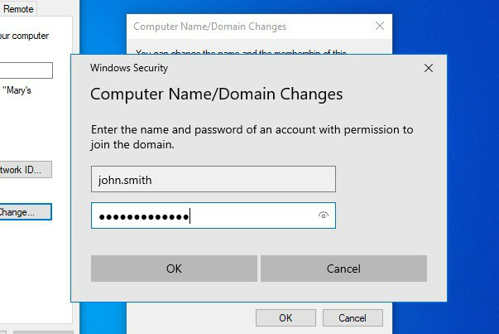

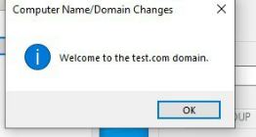

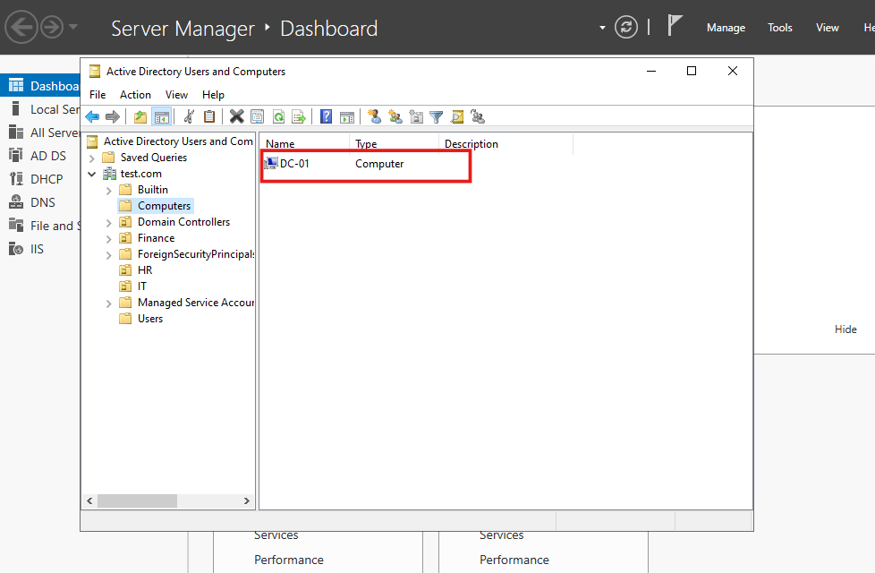

#### **b. Verification:**

* Log in to the VM using the domain user credentials to test the domain join functionality.

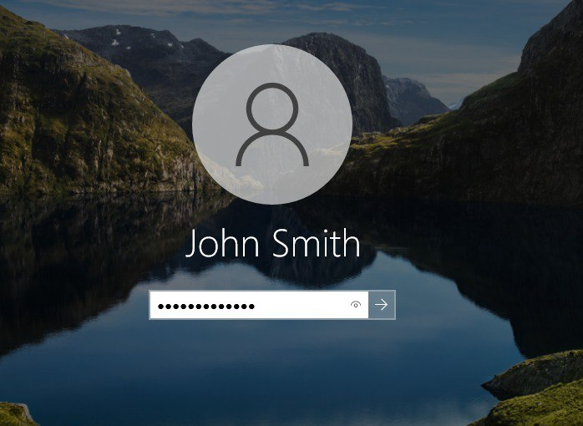

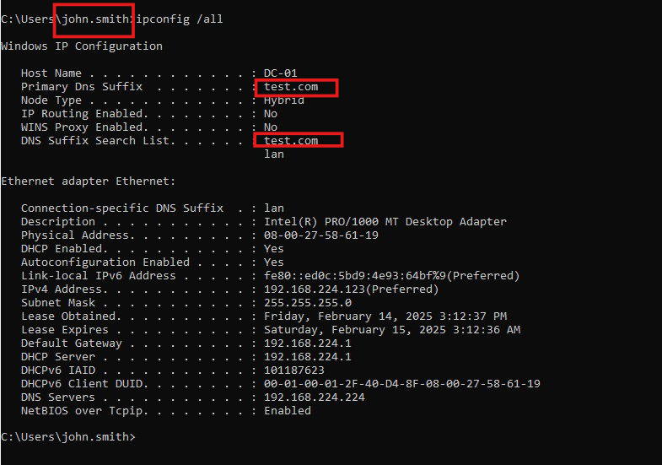

* Test user access and permissions based on security group memberships and group policies.

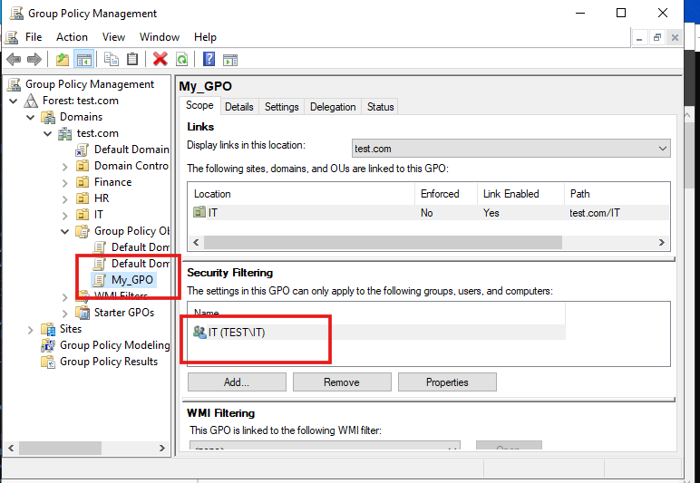

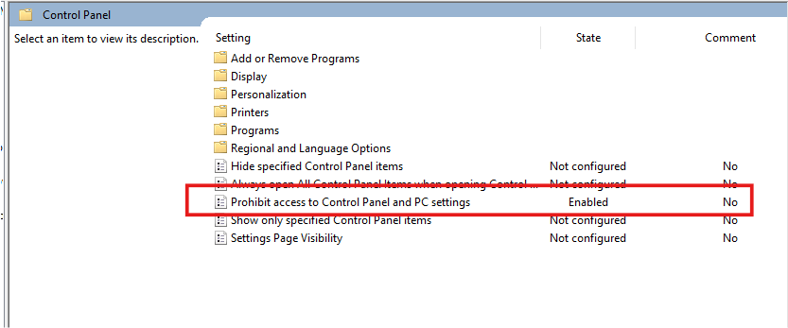

Try open Control Pannel as IT’s member

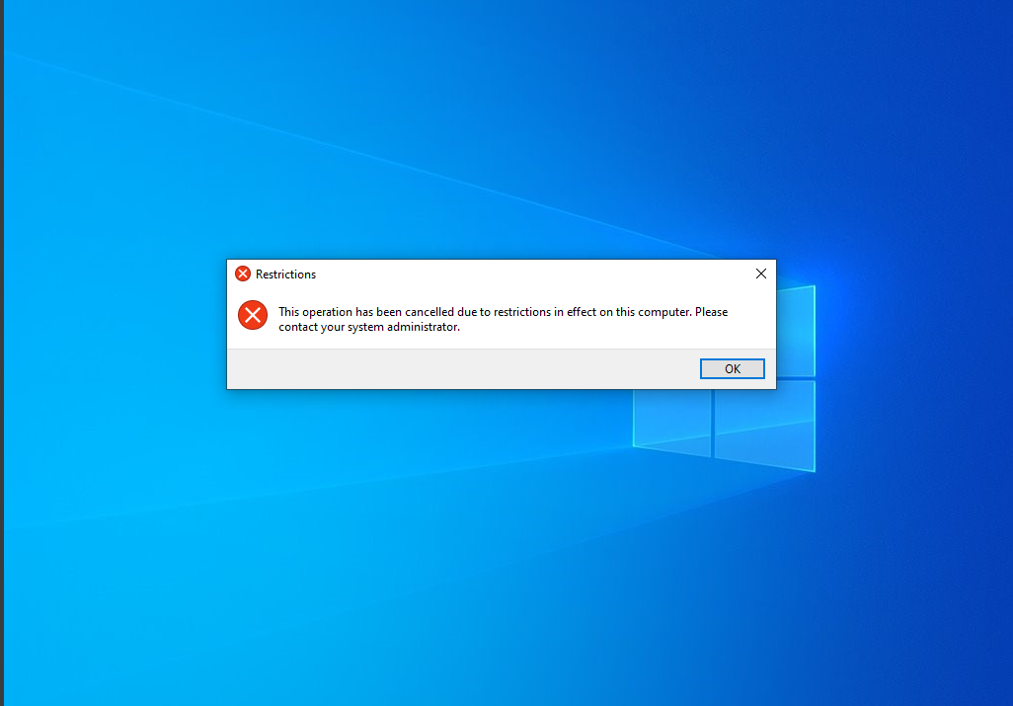

### 

### 

### 

### 

### 

### **3. Penetration Testing with Kali Linux**

#### **a. Information Gathering:**

##### **Nmap:** Perform network scanning using Nmap to gather information about the domain controller.

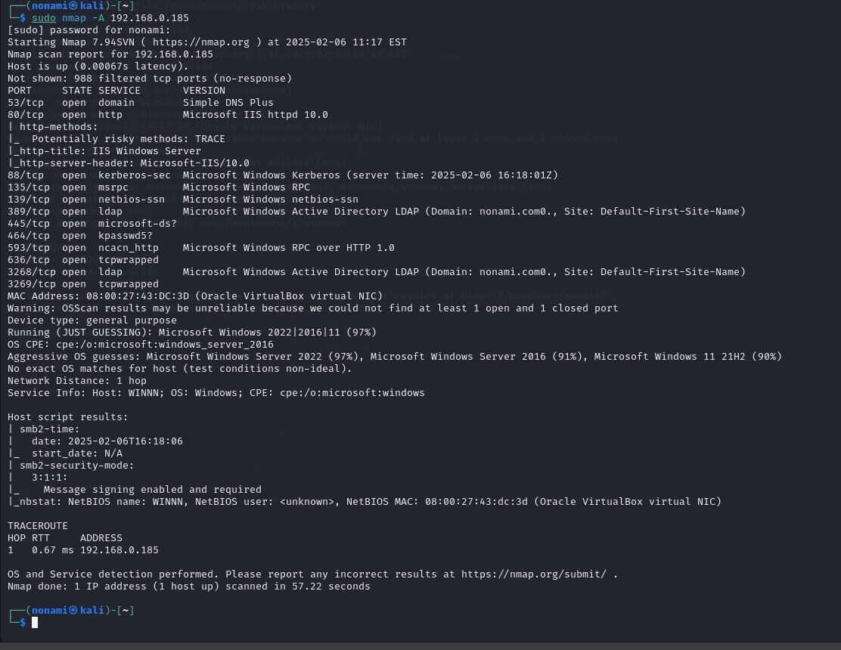

##### 

##### 

##### **Enum4linux-ng:** Use Enum4linux-ng to gather information about the Active Directory environment.

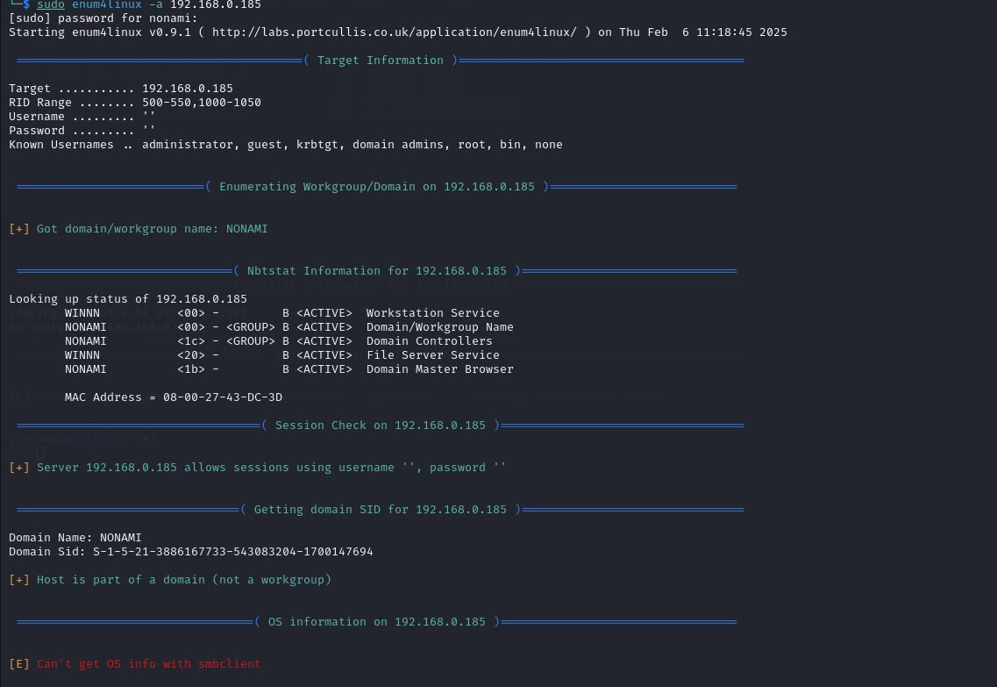

#### 

#### 

#### 

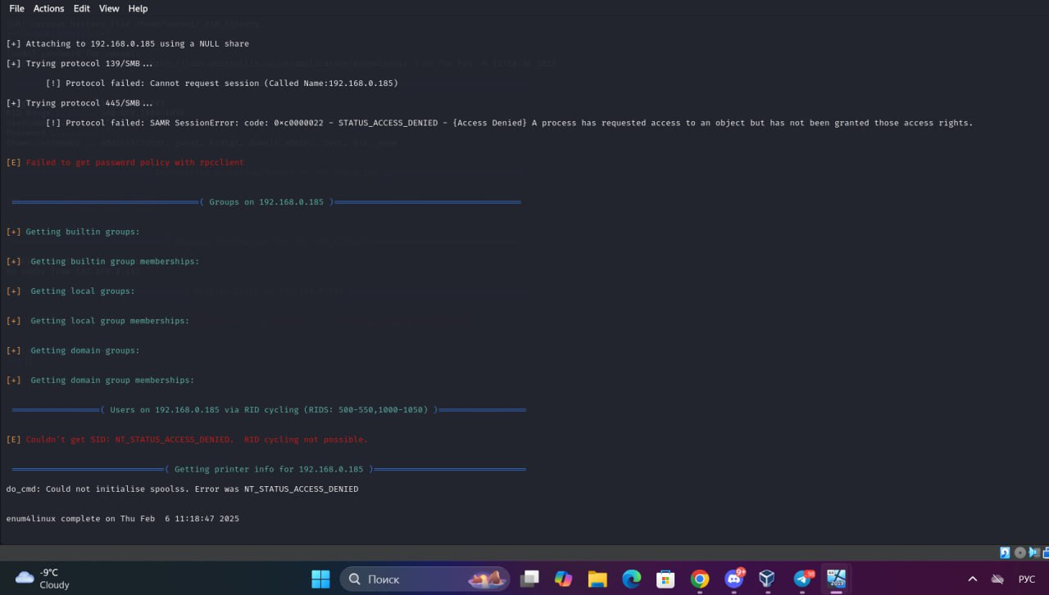

#### **b. Exploitation:**

#### **CrackMapExec (CME):** Use CrackMapExec to identify and exploit SMB shares in the environment.

CrackMapExec (CME) is a powerful post-exploitation tool used by penetration testers and red teamers to automate the assessment of security in Active Directory (AD) environments. It is designed to exploit and enumerate vulnerabilities in Windows networks, particularly those using SMB, LDAP, WinRM, and other protocols.

#### 

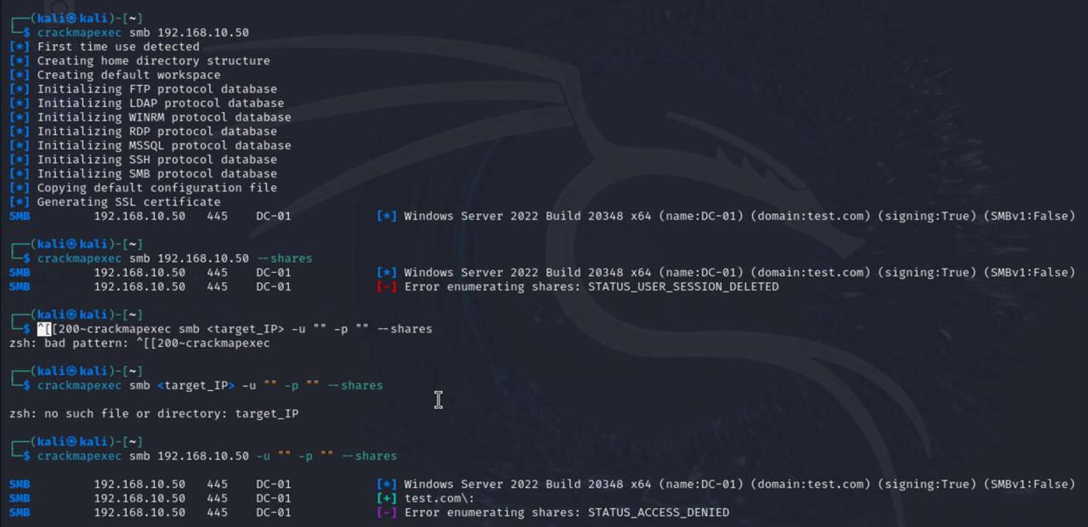

##### **Mimikatz:** Perform credential dumping to extract passwords and hashes.

Mimikatz is a powerful post-exploitation tool used for credential extraction and privilege escalation on Windows systems. It can retrieve plaintext passwords, hash dumps, Kerberos tickets, and more. Below are some common usages.

**Check if running as Administrator**



The *token::elevate* command in Mimikatz is used to elevate the privileges of the current process to that of a process with SYSTEM privileges. It allows you to impersonate a security token with more permissions than your current one.

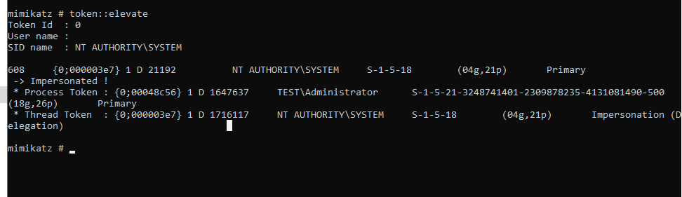

*lsadump::lsa /patch* is used todump secrets from the Local Security Authority (LSA) memoryby patching lsasrv.dll in memory. This allows Mimikatz to extract sensitive credentials that are otherwise protected by the Local Security Authority Subsystem Service (LSASS).

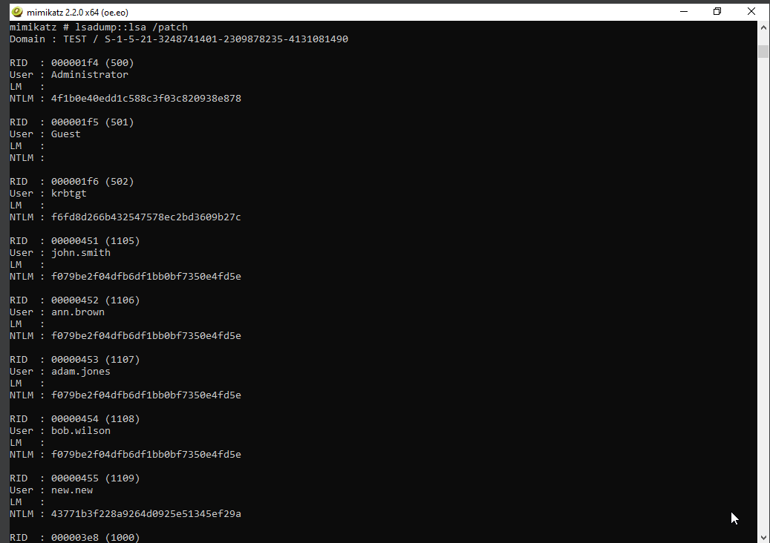

*Lsadump::sam —-* Dumps local user NTLM hashes from SAM

|  |
| --- |

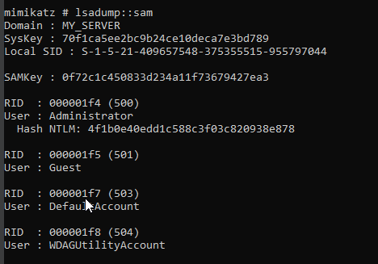

***sekurlsa::logonpasswords***command in Mimikatz is used to extract plaintext passwords, NTLM hashes, and Kerberos tickets from LSASS memory.

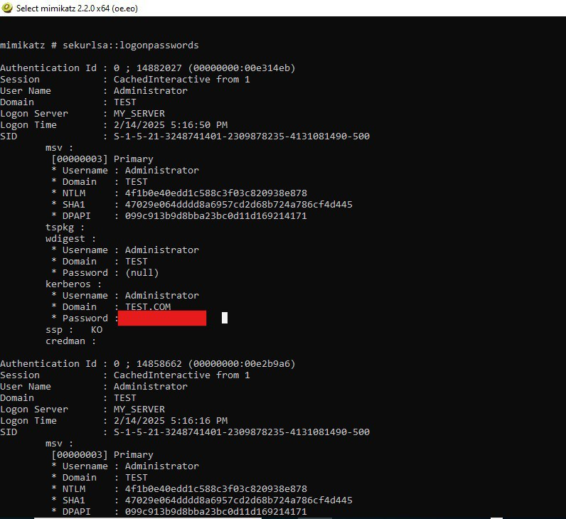

##### **Kerberoasting:** Use Impacket’s GetUserSPNs.py script to extract Service Principal Names (SPNs) for Kerberoasting.

Kerberoasting is an attack technique used in Active Directory (AD) environments to extract and crack Kerberos TGS (Ticket Granting Service) tickets for Service Principal Names (SPNs).

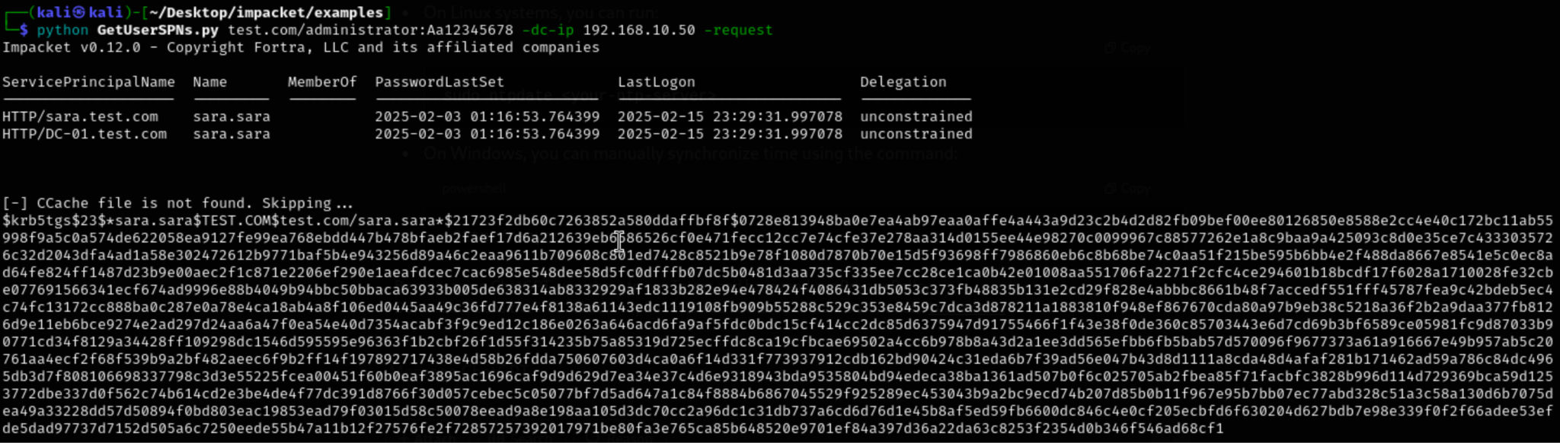

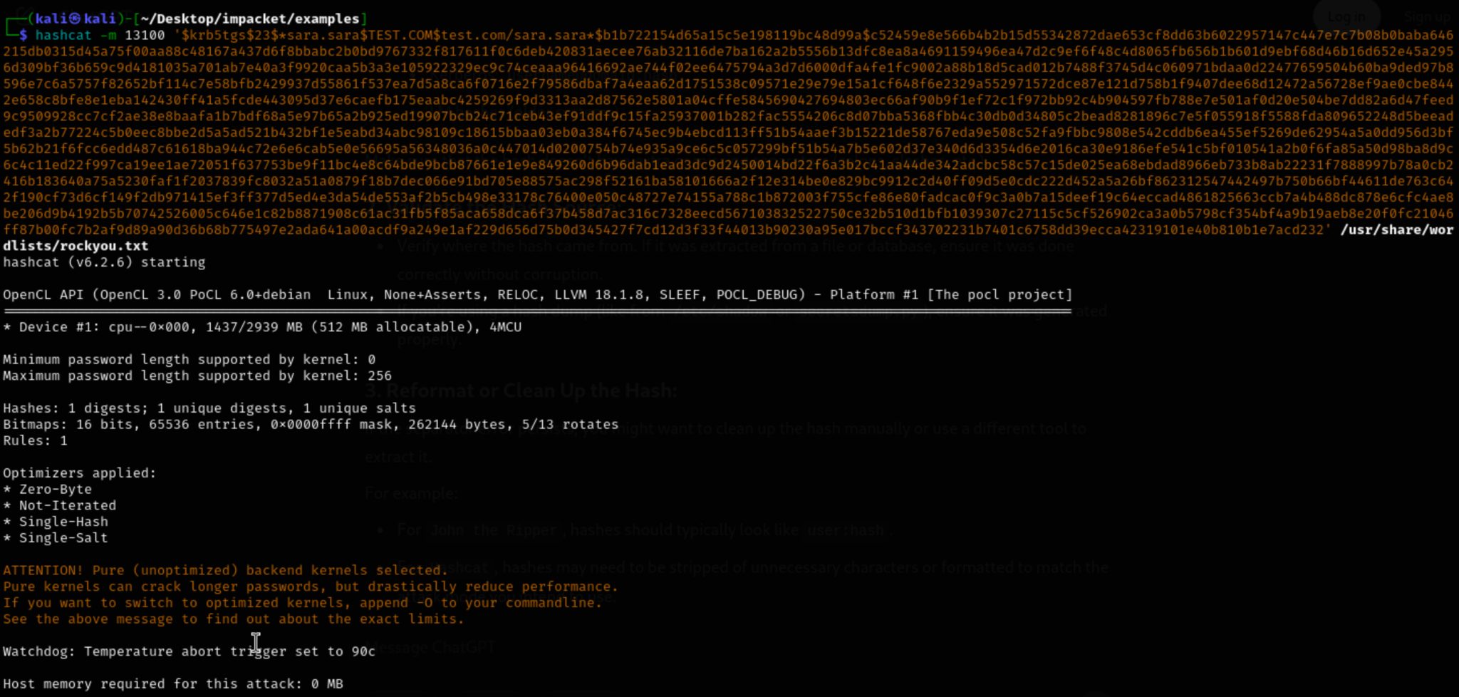

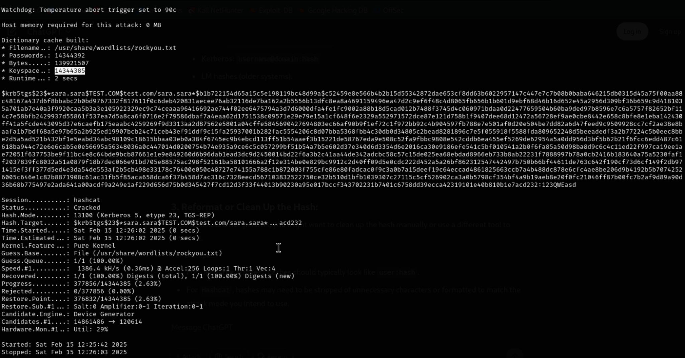

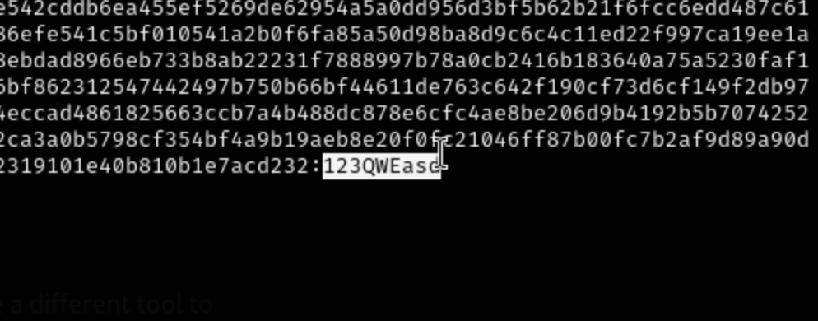

#### 

#### **c. Lateral Movement:**

##### **Pass-the-Hash (PTH):** Use Mimikatz to pass hashed credentials and gain access to other systems.

Pass-the-Hash (PTH) is a hacking technique that allows an attacker to authenticate to a system without knowing the user's password—instead, they use the NTLM hash of the password.

**Sekurlsa** is a module in Mimikatz, a powerful post-exploitation tool used to extract credentials, hashes, and other sensitive information from Windows systems. Specifically, the sekurlsa::pth command in Mimikatz is used to perform a Pass-the-Hash (PTH) attack.

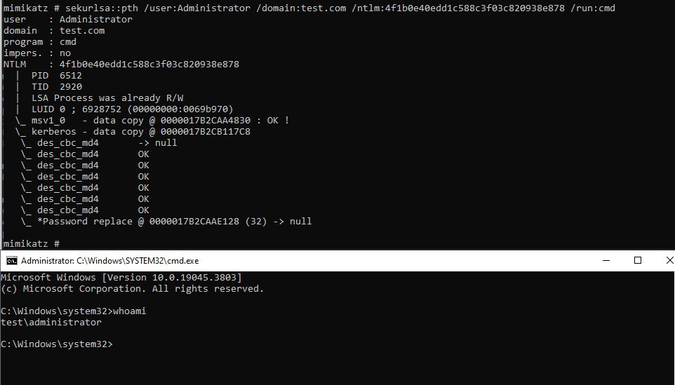

##### **WinRM Exploitation:** Exploit WinRM to execute commands remotely on other systems.

WinRM Exploitation (Windows Remote Management) is a common attack vector that allows attackers to interact with Windows machines remotely using HTTP or HTTPS. Exploiting WinRM typically involves leveraging misconfigurations, weak credentials, or vulnerabilities in the service to gain unauthorized access or escalate privileges.

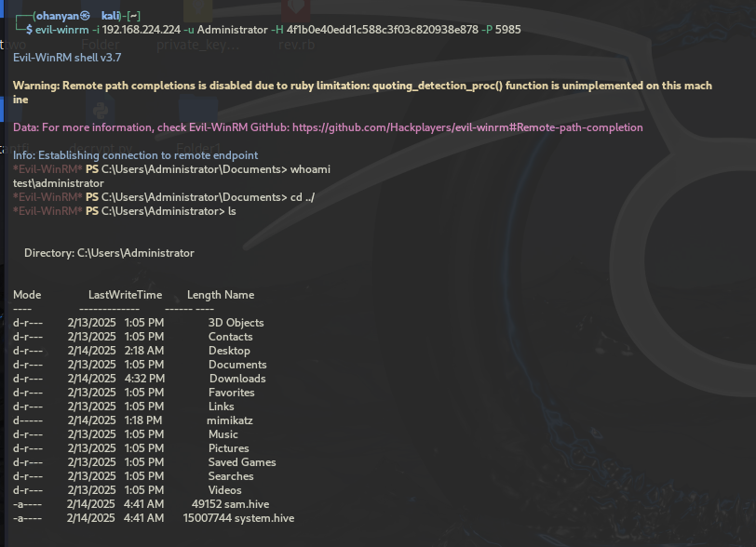

#### 

#### 

#### **d. Persistence:**

##### **Backdoor Account Creation:** Create a hidden administrative account to maintain persistence.

##### 

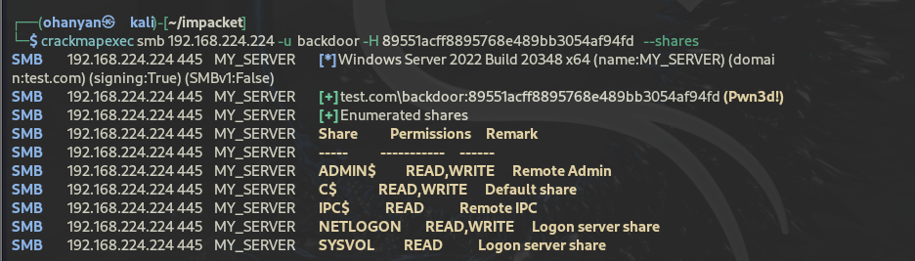

#### 

##### 

##### 

##### **Analysis:**

##### **BloodHound:** Use BloodHound to map Active Directory relationships and identify privilege escalation paths.

**BloodHound Data Collection (Sharpening)**

**SharpHound** is a C# tool that gathers information about the AD environment, including user permissions, group memberships, trusts, and more.

Run **SharpHound** to collect Active Directory data (group memberships, admin rights, trusts).

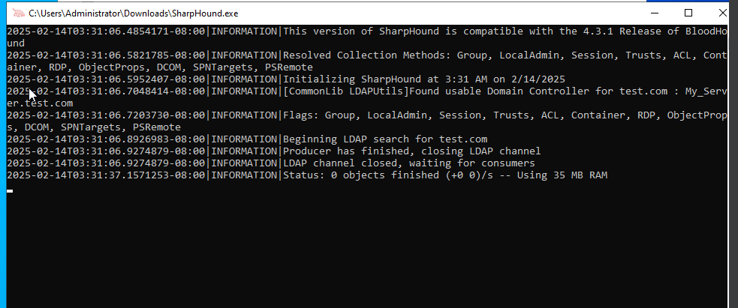

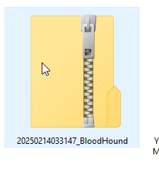

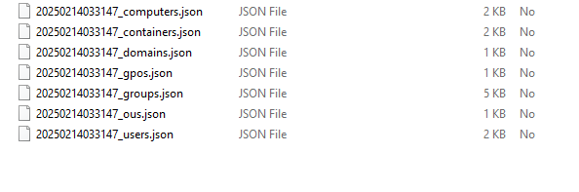

**Install BloodHound and Neo4j on Kali Linux**

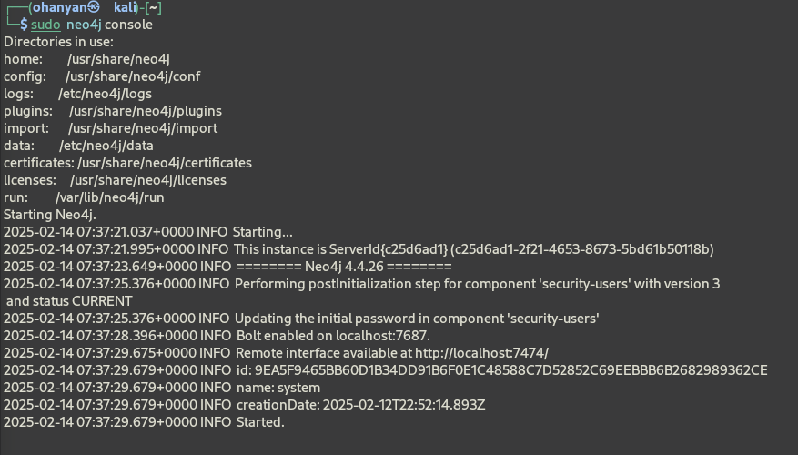

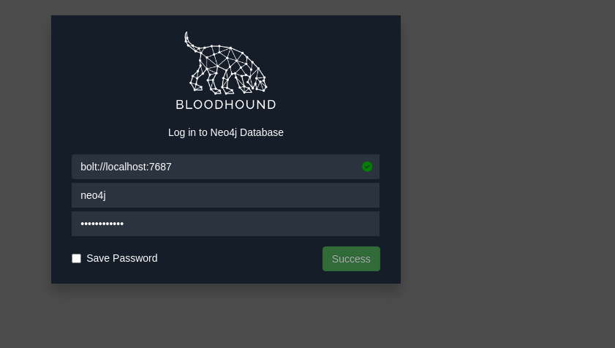

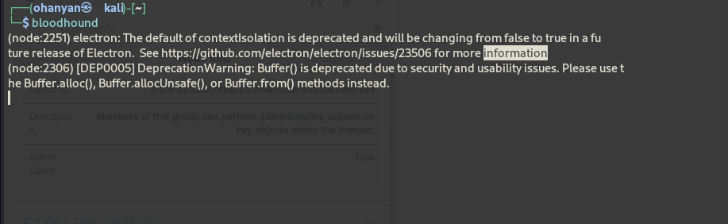

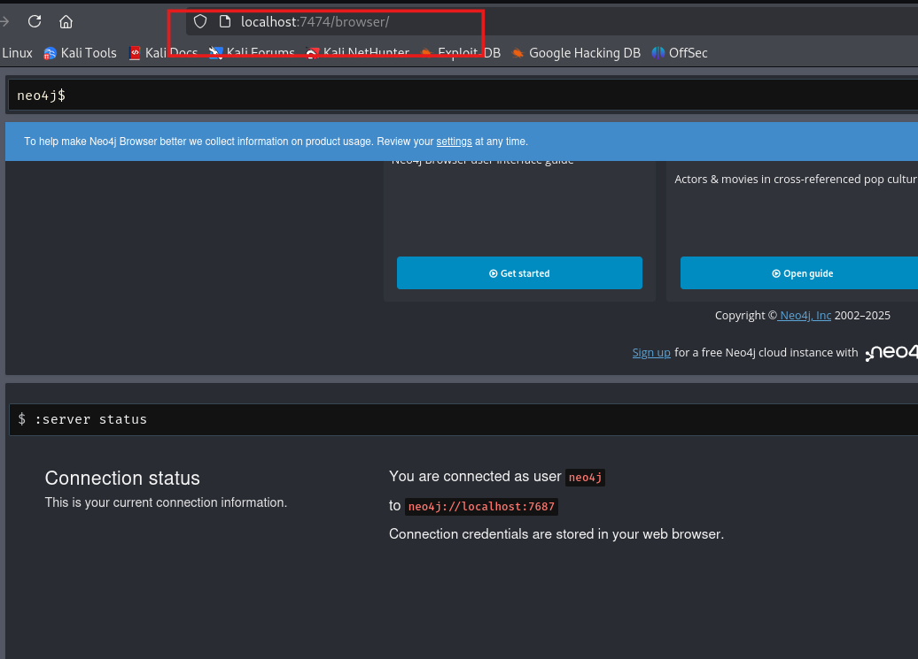

In the context of BloodHound, Neo4j stores all the collected Active Directory data (such as users, groups, permissions, and attack paths). The BloodHound web interface (localhost:5000) connects to Neo4j on localhost:7474 to fetch and visualize that data.

**Visualize Active Directory Relationships in BloodHound**

